**Lightning Experience Migration Project Plan**

**The #AwesomeCo Lightning Experience Migration (“Lightning Project”) will occur in two core phases:**

Phase I: Analyze the current state of our SFDC instance and outline where it is possible to migrate, where it is not possible to migrate, and build a roadmap with milestones and a clear understanding of the ROI to present to stakeholders for approval

Phase II: Complete the design in a developer sandbox (per milestone documentation) and then roll out QA testing in Full Sandbox, and provide training and roll out plan to all users that are affected the week before go-live

The overarching theme of the Lightning Project implementation is to migrate the #AwesomeCo teams onto the awesome new Lightning Experience UI where possible. We have to analyze the current state and understand the limitations of Lightning Experience UI (such as it does not support custom Java and URL buttons yet!). Our deliverable will include a full analyses and milestone project plan and a rollout project plan with go-live dates and a communication plan for the affected users (including training schedule!).

In the following pages we will track specific Phase I and II requirements as well as functionality and tasks that will be assessed and executed during future phases of the Lightning Project.

**A successful implementation of this Lightning Project should entail:**

1. Understanding our current state and limitations of the Lightning UI
2. Leveraging project planning to outline our milestones and deliverables
3. A universal acceptance that the migration will bring value to the teams that need it!

**Core Requirements Assessment - The Kickoff Meeting Agenda (set expectations!)**

1. Review Team Charter and role assignments (personas!)
2. Review project charter information (dependencies, risks, assumptions, etc.)
3. Review Current State, analyze existing processes and identify process improvement
4. Business and Functional Requirements review and brainstorming (future state)
5. Agree on Action Items for next steps and stakeholder buy in

This Business and Functional Requirements document (attached) for the Lightning Project is a documented representation of the project scope and objectives. It includes specific needs that will be incorporated into the new UI and/or the business functions that must be modified or created to satisfy the business need (and identifies if each will be included in Core deliverable or a future phase).

**The Lightning Experience UI Analyses**

The [Lightning Experience Trailhead module](https://developer.salesforce.com/trailhead/lex_admin_migration/lex_migration_introduction/lex_migration_introduction_whatis) outlines exactly what it means to enable Lightning Experience in your org. Read this page (even if you don’t want to earn the badge, at least read through this)!

[Deciding if Lightning Experience is right for you](https://developer.salesforce.com/trailhead/lex_admin_migration/lex_migration_introduction/lex_migration_introduction_rightforme) is another trailhead module that will help you wrap your brain around what this implementation means exactly!

So now we know we have the Classic and Lightning user interface (UI).

Now we know that **Lightning Experience does not support Custom Javascript and URL Buttons**. Let me say that again, Lightning Experience does not support Custom Javascript and URL Buttons. This is a big problem for many organizations! Per Trailhead, here is a list showing when Lightning Experience might be right for you vs. when Salesforce Classic might be right for you:



We also know Lightning is not available to a user unless the administrator has enabled it! And we get to choose which users get access to Lightning (and which don’t). As salesforce.com admins we need to figure out which profiles should get access first and why, what is our strategy exactly? For example from the chart above, maybe the sales team can be migrated to Lightning but the service team stays on classic!!

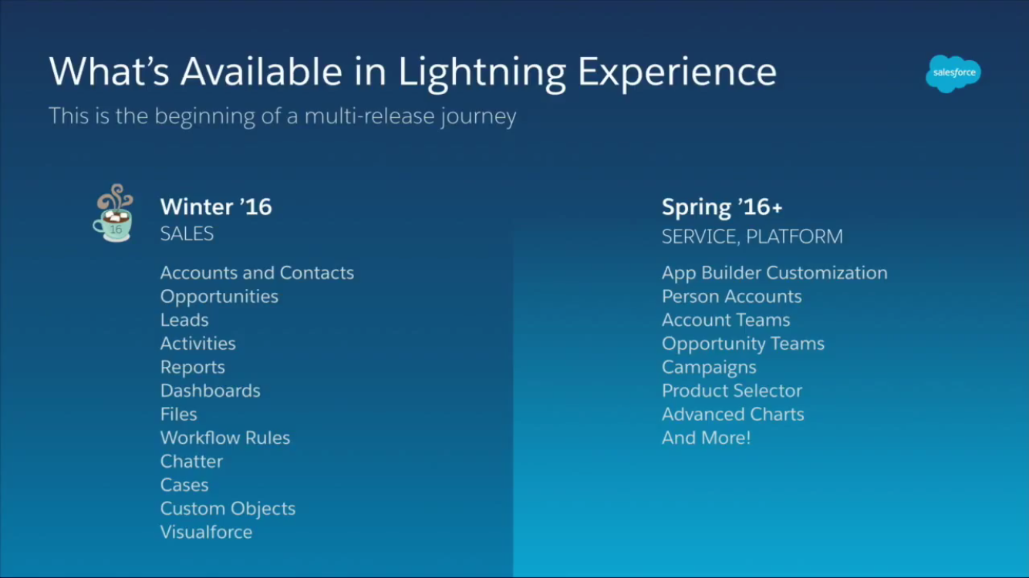

To get a full understanding of what Lightning Experience please complete all of the [Lightning Experience Trailhead](https://developer.salesforce.com/trailhead/trail/lex_admin_implementation) modules now!

[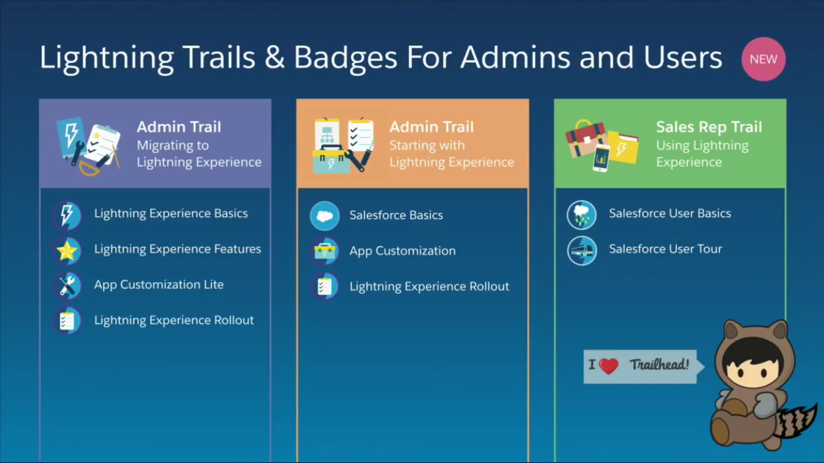](https://developer.salesforce.com/trailhead/trail/lex_admin_implementation)

**Team Charter (and Project Role Assignments):**

**Identify the key people on each team to be the business owner/SME/Super Users**

[Enter Name – primary business sponsor]

* + - Senior Sponsor: Articulate the vision of the project and provide support for resource requirements. Aid the team in driving the process modifications required for adoption of the resulting changes.
    - Business Owner: Provide project oversight. Aid the team in driving the process modification required for adoption of the resulting changes. Secure the resources and funding needed for the development, implementation integration and rollout. Remove organizational roadblocks.

[Enter your name]

* + - Project Manager: Responsible for development of requirements, management of project scope, schedule and budget; and securing project resources, both internally and externally, to complete project. Reports progress and escalates issues as necessary to Business Owner and Project Sponsor(s).
    - Salesforce.com Administrator: Responsible for system design, quality assurance testing, conducting initial training sessions for all users and continual support and administration of the technology.

[Enter Name]

* + - Senior Sponsor: Articulate the vision of the project and provide support for resource requirements. Aid the team in driving the process modifications required for adoption of the resulting changes.

[Enter Name – Executive Assistant to the CEO]

* + - Super User: participate in all project activities, work with team to define and document business and functional requirements and continual enhancements. Participate in systems and training documentation development and rollout as needed.

[Enter Name – VP1]

* + - Subject Matter Expert: provide subject matter expertise regarding business needs.

[Enter Name]

* + - Subject Matter Expert: provide subject matter expertise regarding business needs.
    - Super User: participate in all project activities, work with team to define and document business and functional requirements and continual enhancements. Participate in systems and training documentation development and rollout as needed.

[Enter Name – VP2]

* + - Subject Matter Expert: provide subject matter expertise regarding business needs.

[Enter Name – Executive Assistant to VP1/2]

* + - Super User: participate in all project activities, work with team to define and document business and functional requirements and continual enhancements. Participate in systems and training documentation development and rollout as needed.

**Why we decided that migrating to the Lightning Experience is important?**

* Lightning Experience is a more productive user experience designed to help our sales team close more deals and sell faster and smarter
* Lightning Experience is a Salesforce Admin’s dream-come-true: Everything has been rearranged into a logical category. For example, you’ll no longer need to go to Customized to manage standard objects and Create to manage custom objects. Objects are objects and they will now all be located in the same place!
* Fully customizable home page and page layout components; we make a change to a component on the desktop and mobile is automatically updated. Wow!!
* Insights brings news and information from top news networks and social media straight to your home page. This helps Sales users stay on top of the very latest information about their Accounts.
* Opportunity Board is a newly designed experience giving Sales users the ability to manage their pipeline by dragging and dropping their opportunities from one stage to another on the board.
* Improved List Views embedded charts bring more power to list views making it easy for Sales users to visualize their data and make decisions. (No more inline editing though! But worth the tradeoff!)
* New Dashboards bring one of the most requested changes on the Ideas boards to Salesforce. With Lightning Experience dashboards now go beyond the limit of 3 columns. As many as 9 columns can be used for dashboards.

**\*\*Summaries copied from** [**this blog**](http://blogs.perficient.com/salesforce/2015/09/15/df15-new-in-sales-cloud-lightning-experience-a-new-ui/#more-8898) **,** [**Brent Downey’s post**](https://www.salesforce.com/blog/2015/09/omg-salesforce-lightning.html)**, and** [**Trailhead**](https://developer.salesforce.com/trailhead/trail/lex_admin_implementation)**\*\***

**What does this mean for our #AwesomeCo users?**

1. The sales team can be more productive with the improved UI because it is designed with them in mind! They can quickly modify and report on their opportunities and accounts/contacts without having to rely on reports. Once the use the new lightweight UI, the old UI instantly feels heavy and cumbersome!
2. The new UI allows us to have conversations within the opportunity / account records that are easier to interact with, making us all more productive and engaged.
3. Admins can deploy awesome page layouts and features on desktop and mobile quickly and dynamically.
4. Sales teams can easily bring in news and information from news networks and social media so they don’t have to go outside Salesforce for this information!

**Risks**

1. The Lightning Experience does not support our Java buttons or custom URL buttons. A contingency plan needs to be in place for the migration process. We have to design for all of these buttons and migrate them to process builder or APEX triggers before turning on the new UI
2. Apps from the AppExchange might not work initially until they provide us an upgrade with Lightning Experience support. This means we have to do our research for any existing app to ensure the migration will not break them!

**Constraints**

1. Resource constraints – dedicating the right personnel to this project while maintaining a consistently high service level on existing responsibilities
2. Need to develop an implementation schedule that allows for appropriate performance testing and user acceptance while recognizing when resources are extremely tied up with day-to-day responsibilities.

**Current State Analyses**

Now identify the different teams in our Salesforce org and do a risk analyses as shown below based on what we have learned about limitations and functionality of the Lightning Experience:

|  |  |  |  |
| --- | --- | --- | --- |
| Team | Stay in Classic | Lightning Eligible | Risks / Lightning UI limitations |
| Sales |  | x | Three Java buttons to migrate to Trigger/ Process Builder and one custom URL button for creating contracts using Conga (need to contact Conga support) |
| Revenue Management |  | x | One Java button needs to migrate to Trigger/ Process Builder |
| Merchandising/ Marketing | x |  | Campaigns not supported yet |
| Service | x |  | Service Console not supported |
| Legal |  | x | One Java button needs to migrate to Trigger/ Process Builder |
| Accounting |  | x | One Java button needs to migrate to Trigger/ Process Builder |

|  |  |
| --- | --- |
| **Lightning Migration - Business & Functional Requirements** | |
| **ID#** | **Requirement** |
| **CORE** | **Write the milestone documentation with dates we plan for going live on each feature (i.e. do we plan to go live with Sales first or a smaller team, we can do this because Lightning Experience can be turned on based on Permission Sets and/or by Profile). See next page for example milestone chart!** |
| **BR1** | **Migrate Sales Team to Lightning Experience UI** |
| **F1** | Three Java buttons to migrate to Trigger/ Process Builder (complete work in Dev Sandbox) |
| **F2** | one custom URL button for creating contracts using Conga (need to contact Conga support) If Conga does not support migration we will have to wait to proceed (and if there is no workaround offered from Salesforce such as allowing a user to switch to classic when working on contracts and blocking contracts from new UI?) |
| **F3** | Quality Assurance Testing in Full Sandbox (migrate from Dev Sandbox to Full for testing) |
| **BR2** | **Migrate Revenue Management Team to Lightning Experience UI** |
| **F4** | One Java buttons to migrate to Trigger/ Process Builder (complete work in Dev Sandbox) |
| **F5** | Quality Assurance Testing in Full Sandbox (migrate from Dev Sandbox to Full for testing) |
| **BR3** | **Migrate Legal and Accounting to Lightning Experience UI** |
| **F6** | Two Java buttons to migrate to Trigger/ Process Builder (complete work in Dev Sandbox) |
| **F7** | Quality Assurance Testing in Full Sandbox (migrate from Dev Sandbox to Full for testing) |
| **BR4** | **Mobility Functionality** |
| **F8** | Ensure we are up to speed on mobile functionality during QA Testing |
| **F9** | Take any trainings on Premier Support or YouTube, Trailhead to ensure all features are understood and enabled as necessary |
| **BR5** | **Collaboration and communication** |
| **F10** | Chatter |
| **F11** | Knowledge Documentation |
| **BR6** | **Training (user adoption)** |
| **F12** | Ensure users are engaged with multiple training sessions and quick tips. |
| **F13** | Enable chatter "town hall" group so that users can post questions as they work --responses are then captured for the future and other users can benefit from reading the posts |
| **F14** | Usability Testing (w/immediate enhancements as necessary) |
| **BR** | **Project close out** |
| **F15** | Document lessons learned |
| **F16** | Write close out doc explaining how continual enhancement projects will be planned |

|  |  |  |
| --- | --- | --- |
| **Lightning Migration - Milestones** | | |
| **ID#** | **Milestone** | **Requirement** |
| **BR1** | **28-Feb-16** | **Migrate Sales Team to Lightning Experience UI** |
| **F1** | **1-Jan-16** | Three Java buttons to migrate to Trigger/ Process Builder (complete work in Dev Sandbox) |
| **F2** | **15-Jan-16** | one custom URL button for creating contracts using Conga (need to contact Conga support) If Conga does not support migration we will have to wait to proceed (and if there is no workaround offered from Salesforce such as allowing a user to switch to classic when working on contracts and blocking contracts from new UI?) |
| **F3** | **15-Feb-16** | Quality Assurance Testing in Full Sandbox (migrate from Dev Sandbox to Full for testing) |
| **BR2** | **31-Mar-16** | **Migrate Revenue Management Team to Lightning Experience UI** |
| **F4** | **1-Mar-16** | One Java buttons to migrate to Trigger/ Process Builder (complete work in Dev Sandbox) |
| **F5** | **15-Mar-16** | Quality Assurance Testing in Full Sandbox (migrate from Dev Sandbox to Full for testing) |
| **BR3** | **30-Apr-16** | **Migrate Legal and Accounting to Lightning Experience UI** |
| **F6** | **1-Apr-16** | Two Java buttons to migrate to Trigger/ Process Builder (complete work in Dev Sandbox) |
| **F7** | **15-Apr-16** | Quality Assurance Testing in Full Sandbox (migrate from Dev Sandbox to Full for testing) |
| **BR4** | **1-Jan-16** | **Mobility Functionality** |
| **F8** | **1-Jan-16** | Ensure we are up to speed on mobile functionality |
| **F9** | **1-Jan-16** | Take any trainings on Premier Support or YouTube, Trailhead to ensure all features are understood and enabled as necessary |
| **BR5** | **Ongoing** | **Collaboration and communication** |
| **F10** | **Ongoing** | Chatter |
| **F11** | **Ongoing** | Knoweledge Documentation |
| **BR6** | **Ongoing** | **Training (user adoption) - Deliver for each team the week before go-live** |
| **F12** | **Ongoing** | Ensure users are engaged with multiple training sessions and quick tips. |
| **F13** | **Ongoing** | Enable chatter "town hall" group so that users can post questions as they work --responses are then captured for the future and other users can benefit from reading the posts |
| **F14** | **Ongoing** | Usability Testing (w/immediate enhancements as necessary) |
| **BR** | **30-Apr-16** | **Project close out** |
| **F15** | **30-Apr-16** | Document lessons learned |
| **F16** | **30-Apr-16** | Write close out doc explaining how continual enhancement projects will be planned |

**Sign Off**

**Business Owner/Senior Sponsor**

_________________________________

[Enter Name]

[Title]

**Project Manager**

__________________________________

[Your Name]

Salesforce.com Administrator